**IMPLEMENTATION OF 5G MODULATION TECHNIQUE (UFMC) USING USRP**

**A PROJECT REPORT**

***Submitted by***

**MUTHUKUMAR S(2015105589)**

**MANO K(2015105011)**

**LOGESHWARAN S (2015105549)**

**AJITHKUMAR R (2015105538)**

***in partial fulfillment for the award of the degree***

***of***

**BACHELOR OF ENGINEERING**

***in***

**ELECTRONIC AND COMMUNICATION ENGINEERING**

**COLLEGE OF ENGINEERING GUINDY**

**ANNA UNIVERSITY:: CHENNAI 600 025**

**MAY 2019**

**ANNA UNIVERSITY: CHENNAI 600 025**

**BONAFIDE CERTIFICATE**

Certified that this project report “ **IMPLEMENTATION OF 5G MODULATION TECHNIQUE (UFMC) USING USRP ”**  is the bonafide work of “ **MUTHUKUMAR S(2015105589), MANO K(2015105011), LOGESHWARAN S(2015105549), AJITHKUMAR R(2015105538)** ” who carried out the project work under my supervision.

**SIGNATURE SIGNATURE**

**Dr S. MUTTAN Dr M.A. BHAGYAVENI**

**HEAD OF THE DEPARTMENT,** PROFESSOR,

ECE DEPARTMENT, ECE DEPARTMENT,

COLLEGE OF ENGINEERING, COLLEGE OF ENGINEERING,

GUINDY, GUINDY,

CHENNAI-25. CHENNAI-25.

**ACKNOWLEDGEMENT**

We would like to express our sincere thanks to our Head of the Department, **Dr S. MUTTAN** and all the staff member of ECE for their generosity in allowing us to access the labs and their kind support without this project would not have been possible.

It is great pleasure to express our deep sense of gratitude to our guide

**Dr M.A. BHAGYAVENI** , Department of ECE ,College of Engineering Guindy, Anna University ,Chennai for his guidance ,valuable suggestions, constructive criticism and persistent encouragement throughout the project.

We also thank our project coordinator **, Mrs** **J.MADHUMITHA** for conducting periodic reviews that helped us in assessing our process.

We would like to extend our special thanks to all our friends who have been of immense help at all important junctions of the project. Finally we would also like to thank our parents who have supported us financially and morally through the course of our project.

MUTHUKUMAR S(2015105589)

MANO K(2015105011)

LOGESHWARAN S (2015105549)

AJITHKUMAR R (2015105538)

**TABLE OF CONTENTS**

**CHAPTER NO. TITLE PAGE NO**

**ABSTRACT vi**

**LIST OF FIGURES vii**

**LIST OF TABLES viii**

1. **INTRODUCTION 1**
2. **LITERATURE SURVEY 3**
3. **UNIVERSAL SOFTWARE RADIO**

**PERIPHERAL 5**

3.1UNIVERSAL SOFTWARE RADIO

PERIPHERAL (USRP) 5

3.2 USRP BLOCK DIAGRAM 5

3.3 DESIGN METHODOLOGY 4

3.4 COMPARASION OF

OFDM AND UFMC8

**4. HARDWARE AND SOFTWARE**

**REQUIREMENTS 10**

4.1 HARDWARE DESCRIPTION 10

4.1.1 UNIVERSAL SOFTWARE

RADIO PERIPHERAL(USRP-2920) 10

4.1.2 SPECIFICATION OF NI USRP 11

4.1.3 USRP BLOCK DIAGRAM 12

4.1.4 TRANSMITTER PATH 12

4.1.5 RECEIVER PATH 13

4.2 SOFTWARE DESCRIPTION 13

4.2.1 GETTING STARTED WITH LABVIEW

VIRTUAL INSTRUMENTS 13

4.2.2 LAUNCHING LABVIEW 14

4.2.3 OPENING NEW VI FROM TEMPLATE 14

4.2.4 BASIC TRANSMITTER AND

RECEIVER DESIGN 16

**5. TEST BED IMPLEMENTATION OF UFMC 28**

5.1 TRANSMITTER AND RECEIVER

DESIGN IN LABVIEW 28

5.1.1 TRANSMITTER VIs INTERCONNECTION 29

5.1.2 RECEIVER VIs INTERCONNECTION 32

**6.** **CONCLUSION AND FURTURE WORK**  37

**REFERENCE 38**

**ABSTRACT**

This projects describes the aspects of software defined radio implement of Universal FilteredMulti Carrier (UFMC) system and highlights the merits of different modulation methods for the emerging fifth generation (5G) Wireless Communication Systems. . Our current 4G systems rely on the OFDM waveform, Orthogonal Frequency Division Multiplexing (OFDM) is an excellent choice for fourth generation (4G). 4G modulation methods suffer from the problem of high Peak to Average Power Ratio (PAPR). Side band leakage is another problem in OFDM, it is not capable of supporting the diverse applications 5G will offer. The traffic generated by 5G is expected to have very different characteristics and requirements when compared to current wireless technology. As result other multiple access schemes are being investigated. The way to overcome the known limitations of OFDM is UFMC technique. This project discusses PAPR and Bit Error Rate (BER) of UFMC system for various mapping schemes. Matlab simulations show that BER values for UFMC are increasing with increase in number of bits per subcarrier. BER of UFMC system is less for 4QAM (Quadrature Amplitude Modulation) mapping method when compared to the other mapping methods but PAPR of UFMC is high when compared with OFDM. PAPR for UFMC is 8.237 and for OFDM it is 8.843 at SNR=5dB when 16QAM Mapping is used. For all other mapping methods PAPR of UFMC system is high compared to PAPR of OFDM. Therefore ,the final inference of the project is 16QAM mapping method is the preferable mapping method for UFMC system.

**LIST OF FIGURES**

**FIG NO. TITLE PAGE NO**

3.1 UFMC BLOCK DIAGRAM 5

3.2 TRANSMITTER BLOCK 7

3.3 RECEIVER BLOCK 8

4.1 USRP KIT 10

4.3 USRP BLOCK DIAGRAM 12

4.4 NEW DIALOG BOX 15

5.1 REAL TIME CONNECTION OF

H/W AND S/W 29

5.2 TRANSMITTER 30

5.3 UFMC SIGNAL 31

5.4 UFMC SIMULATION OUTPUT 31

5.5 OFDM SIMULATION RESULT 32

5.6 RECEIVER 33

5.7 PSD OF UFMC 34

5.8 BEFORE EQUALIZATION 34

5.9 AFTER EQUALIZATION 35

5.10 BER OF UFMC 35

**LIST OF TABLES**

**TABLE NO TITLE PAGE NO**

3.3 SYSTEM PARAMETER 6

4.2 SPECIFICATION OF NI

USRP 2920 TRANSCEIVER 11

5.11 BER AND PAPR OF UFMC

FOR DIFFERENT MAPPING

TECHNIQUES AT 5dB SNR 36

**CHAPTER 1**

**INTRODUCTION**

1G is analog technology, and the phones using it had poor battery life and voice quality, little security, and were prone to dropped calls. The maximum speed of 1G technology is 2.4 kbps. Then the 2G telephone technology introduced call and text encryption, along with data services such as SMS, picture messages, and MMS. The maximum speed of 2G with General Packet Radio Service (GPRS) is 50 Kbps. The speed is 1 Mbps with Enhanced Data Rates for GSMs Evolution (EDGE). Before jumping to 4G, 2.5G introduced a new packet-switching technique that was more efficient than 2G technology. This led to 2.75G, which provided a theoretical threefold speed increase. AT&T was the first GSM network to support 2.75G with EDGE in the U.S. The 4G network enables user to make video calling and mobile internet access. The maximum speed of 4G is estimated to be around 2 Mbps for non-moving devices and 484 Kbps in moving vehicles. These developments in communication leads to 4G.

Before we jumping to 4G, it is necessary to understand the requirement of multicarrier modulation over a single carrier modulation. Single carrier modulation uses one carrier to transmit overall data. This technique is widely used in GSM, CDMA 2000. The main goals to prefer this method are battery power and coverage extensions. Single carrier method requires equalizers to achieve high spectral efficiency. Whereas, Multicarrier modulation converts a wideband carrier into multiple orthogonal narrowband carriers. For higher data transmission, wireless communication systems required to incorporate Multicarrier modulation.

4G communication systems such as LTE/LTE Advanced, Wi-MAX uses OFDM, as multi-carrier modulation technique. Although it has efficient implementation and robustness to channel delays as highlights, this method suffers from high PAPR results low efficiency of power amplifier, increases the battery consumption. Moreover, the OFDM spectrum has high out of band side lobes causing problem of low spectral efficiency. To overcome some of these drawbacks new modulation techniques for 5G communication system are considered.

The applications which use 5G communication system require higher data rates, lower latency and efficient spectrum usage. The way to overcome the known limitations of OFDM is UFMC technique. UFMC is generalization of Filtered OFDM and FBMC modulations. In OFDM the total band is filtered and in Filter Bank Multi Carrier (FBMC) individual subcarriers are filtered where as a group of subcarriers (sub bands) are filtered in UFMC. This subcarrier grouping reduces the filter length (when compared with FBMC).

In this project, we implemented the UFMC modulation technique in USRP which enables us to easily modify the modulation and mapping schemes. For that, we used LABVIEW software to build the blocks required to configure the USRP.

By using those blocks, the physical layer properties can be changed and the real time data can be analysed easily.

In chapter 2, few papers related to 5G are listed. In chapter 3, basics of UFMC is demonstrated. In chapter 4, hardware and software requirements, its specifications are given. In chapter 5, the procedure to interface software with hardware and the way to design the transmitter and receiver VIs, its results are demonstrated. In chapter 6, conclusion of this project is discussed.

CHAPTER 2

**LITERATURE SURVEY**

In this paper [2], the waveform design of 4G (based on OFDM) and motivate the need for a redesign to 5G are explained. Both the advent of the Internet of Things (IoT) and the move to user-centric processing are rendering OFDM unfeasible. With FBMC a potential contender has been promoted in recent years. Though FBMC is better suited than OFDM in theory, practical considerations pinpoint many issues of FBMC. Therefore, a new waveform called Universal Filtered Multi-Carrier (UFMC) is introduced for collecting the advantages FBMC is promising while avoiding its drawbacks. In contrast to FBMC, UFMC applies a filtering functionality per sub-band instead of per subcarrier.

In this literature [4], OFDM divides the spectrum into number of orthogonal and non-overlapping subcarriers. In OFDM timing and Carrier Frequency Offset (CFO) errors are high. FBMC is the new modulation technique for 5G to overcome these losses in OFDM

Like OFDM, FBMC is also a multicarrier technique which employs per-subcarrier filtering. FBMC’s improved synchronization and resistance to misalignments of frequency make the waveform an enticing alternative to OFDM. However, the additional filtering requirement, increases the implementation complexity. For short burst uplink communication with high filter length of FBMC is disadvantageous.

In this paper [4], the performance of UFMC signals which is better than OFDM in terms of side lobe attenuation, BER for discrete narrow band networks are compared.

Smart Gradient Project Active Constellation Extension (ACE-SGP), Tone Reservation (TR) methods are used to reduce the PAPR values for FBMC/OQAM signals.

UFMC does not have to use a cyclic prefix, although it can be used to improve the inter symbol interference (ISI) protection using special or unified structure of the frame

In this paper [11], a multi-carrier transmission scheme to overcome the problem of intercarrier interference (ICI) in orthogonal frequency division multiplexing (OFDM) systems is proposed.

In the proposed scheme, called universal-filtered multi-carrier (UFMC), a filtering operation is applied to a group of consecutive subcarriers (e.g. a given allocation of a single user) in order to reduce out-of-band sidelobe levels and subsequently minimize the potential ICI between adjacent users in case of asynchronous transmissions.

. **CHAPTER 3**

**UNIVERSAL FILTERED MULTI-CARRIER(UFMC)**

In this chapter, The basics of UFMC, block diagram, system model and comparation of OFDM and UFMC are explained.

**3.1 UNIVERSAL FILTERED MULTI CARRIER (UFMC)**

Universal filtered multi carrier (UFMC) is a new technology which combines the features of OFDM and FBMC. It is based on frequency division multiplexing FDM. In UFMC, the incoming data stream is distributed into many sub-streams with comparatively lower data rate. This new candidate provides reduced out of band emission and better time frequency synchronization.

**3.2 UFMC BLOCK DIAGRAM**

**Fig 3.1 UFMC block diagram**

The above diagram depicts the architecture of UFMC.

**3.3 DESIGN METHODOLOGY**

Now-a-days UFMC is a highly research involved 5G modulation method. UFMC, a novel multicarrier modulation technique works equivalent to the generality of filtered OFDM and FBMC modulations. Unlike self-subcarrier modulation in FBMC, a group of subcarrier modulation is performed in UFMC. The subcarrier grouping reduces the length of the filter compared with FBMC and also reduces time to perform modulation. QAM type of modulation is used in UFMC. Transmitter block diagram is shown in Fig.3.2 and Receiver blockdiagram of UFMC is shown in Fig.3.3 and the system parameters of UFMC are displayed in Table 3.3

|  |  |
| --- | --- |
| **PARAMETER** | **VALUE** |
| Number of FFT points | 512 |
| Sub band size | 20 |
| Number of sub bands | 10 |
| Sub band offset | 156 |
| Filter length | 44 |
| Side lobe attenuation | 40 |
| Bits per subcarrier | 2,4,6,8 |
| SNR(dB) | 15 |

**Table 3.3: SYSTEM PARAMETERS**

Fig 3.2 explains the transmitter side of the UFMC.UFMC employs the division of full band into sub bands. The modulation technique processes these sub bands individually and each sub band consists of fixed number of subcarriers. The narrowband and closely spaced Individual sub bands undergoes N-point Inverse Fast Fourier Transform (IFFT) to get time domain (xi) of each sub band from Frequency Domain (Xi) of each sub band.

After performing N point IFFT on each sub band the output can be expressed as

|  |  |
| --- | --- |
| *yi* = *IFFT* {*xi* } ….. | (1) |

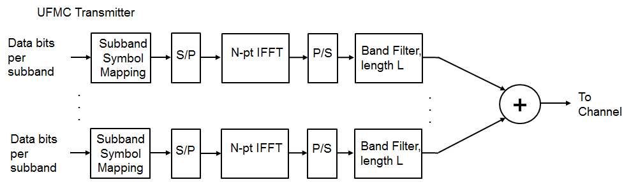

**Fig 3.2 Transmitter block diagram**

Each sub band output resulting from IFFT is filtered by filter length L. The resulting output signal is expressed as

|  |  |
| --- | --- |
| *y* =Η•~ *Q* • *yi* | ……(2) |

H is Toeplitz matrix with dimensions (N+L-1)*N and ~Q represents inverse Fourier matrix.

IFFT operation ensures that the sub band carriers do not interfere. UFMC uses Band filter to perform A Chebyshev filtering operation. Band Filter filters each sub band and each sub band responses summed. The filtering approach in UFMC reduces out of band spectral emission for proper design of filter. Filter with parameterized side lobe attenuation is employed to filter the IFFT output per sub band.

UFMC receiver performs 2N point Fast Fourier Transform (FFT) on data obtained from channel. A guard interval of Zeros is added between successive IFFT symbols(4). This prevents the Inter Symbol Interference (ISI) due Transmitter filter delay. Receiver side process is shown in Fig 3.3.

*Y=FFT{[* ………(4)

Discard even subcarrier points to get N length frequency domain receive signal Y. FFT converts data received in time domain into frequency domain. Equalization nullify the channel effect and reproduces the symbols. 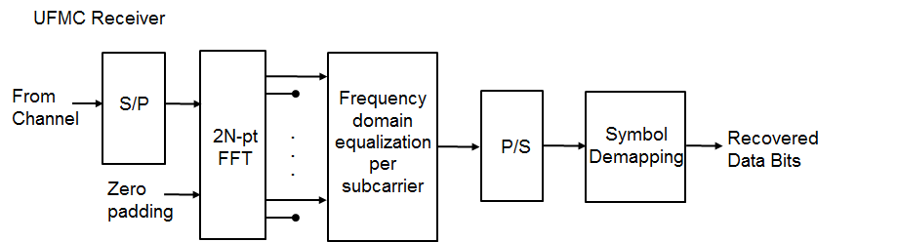

**Fig3.3 Receiver block diagram**

The Symbol demapping is performed after the frequency domain equalization to get the original data bits.

**3.4 COMPARASION OF OFDM AND UFMC**

In the previous two sections we were able to see the characteristics of OFDM and UFMC waveforms. Since UFMC is a derivative of OFDM, a lot of similarities can be seen in their properties.

It is a known fact that OFDM being already used for LTE and LTE-A systems is taken into consideration for future 5G networks also. But the advanced form of OFDM definitely has several advantages over its predecessor. The foremost and obvious difference between the two candidates is that of Cyclic prefix CP. The absence of CP in UFMC reduces the filter length but at the receiver side zero padding is done before applying 2N FFT.

For OFDM, orthogonality in time domain is ensured by the use of cyclic prefix. The advantage of adding CP is that it transforms the convolution of the channel in a circular one. Aside from this advantage the biggest disadvantage that OFDM suffers is the loss of spectral efficiency. Instead of CP, UFMC uses additional per sub-band filters which reduce the spectral side lobe levels outside the sub-band. This increases robustness beside any sources of inter carrier interference. UFMC filters are in the order of an OFDM CP.

OFDM has efficient implementation of (FFT/IFFT) and has simple equalization schemes but spectral efficiency is lost due to cyclic prefixes. The main advantage of UFMC over OFDM is the use of Dolph-Chebyshev filter. Indeed, according to its filter properties the effect of side lobe interference with the adjacent subcarrier can be significantly reduced.

By using this filter two OFDM issues are solved. On one hand there is no need to add guard band because other UFMC symbols would not be disturbed by the side lobe interference. On the other hand, UFMC is more robust to inter-carrier interference and loss of orthogonality would not be a problem anymore.

In terms of PAPR, it was seen that OFDM gives relatively higher PAPR than UFMC. High PAPR is also a draw back and the reason why PAPR should be low is because peaks may be cut-off by transmitter amplifier.

The hardware and software requirements are explained in next chapter.

**CHAPTER 4**

**HARDWARE AND SOFTWARE REQUIREMENTS**

In this chapter the hardware and software required to implement this project is explained. The hardware USRP is one of the SDR in which physical layer properties can be configured easily using the software LABVIEW.

**4.1 HARDWARE DESCRIPTION**

**USRP** is the hardware we used to implement the modulation techniques. The hardware descriptions are discussed here.

**4.1.1 UNIVERSAL SOFTWARE RADIO PERIPHERAL (USRP-2920)**

Fig 4.1 USRP KIT

**Universal Software Radio Peripheral** (**USRP**) is a range of software-defined radios. Most USRPs connect to a host computer through a high-speed link, which the host-based software uses to control the USRP hardware and transmit/receive data. Some USRP models also integrate the general functionality of a host computer with an embedded processor that allows the USRP device to operate in a stand-alone fashion, all USRP products are controlled with the open source UHD driver. USRPs are commonly used with the GNU Radio or LABVIEW software suite to create complex software defined radio systems. USRP 2920 specification is given below in table 4.2

**4.1.2 SPECIFICATION OF NI USRP 2920**

**TABLE 4.2 SPECIFICATION OF NI USRP 2920 TRANSCEIVER**

|  |  |
| --- | --- |
| Frequency range | 50 MHz to 2.2 GHz |
| Frequency step | <1 kHz |
| Maximum output power (Pout) | 50 mW to 100 mW |
| Gain range | 0 dB to 41 dB |
| Maximum instantaneous real time Bandwidth | 20 MHz |
| Maximum I/Q sample rate | 25 MS/s |
| Frequency accuracy | 2.5 ppm |
| Digital-to-analog converter (DAC) | 2 channels, 400 MS/s, 16 bit |
| DAC spurious-free dynamic range (sFDR) | 80 dB |
| Maximum input power (Pin) | 0 dBm |
| Noise figure | 5 dB to 7 dB |
| Analog-to-digital converter (ADC) | 2 channels, 100 MS/s, 14 bit |
| ADC sFDR | 88 Db |

**4.1.3 USRP BLOCK DIAGRAM**

**Fig 4.3 BLOCK DIAGRAM**

The above fig 4.3 depicts the hardware architecture of USRP.

**4.1.4 TRANSMITTER PATH**

In the transmitter path, following process will takes place.

* The host computer synthesizes baseband I/Q signals and transmits the signals to the device over a standard gigabit Ethernet connection.
* The digital upconverter (DUC) mixes, filters, and interpolates the signal to 400 MS/s.
* The digital-to-analog converter (DAC) converts the signal to analog.
* The lowpass filter reduces noise and high frequency components in the signal.
* The mixer upconverts the signals to a user-specified RF frequency.
* The PLL controls the VCO so that the device clocks and LO can be frequency-locked to a reference signal.
* The transmit amplifier amplifies the signal and transmits the signal through the antenna.

**4.1.5 RECEIVER PATH**

In the receiver path, following process will takes place.

* The low-noise amplifier and drive amplifier amplify the incoming signal.
* The phase-locked loop (PLL) controls the voltage-controlled oscillator (VCO) so that the device clocks and local oscillator (LO) can be frequency-locked to a reference signal.
* The mixer down converts the signals to the baseband in-phase (I) and quadrature-phase (Q) components.
* The lowpass filter reduces noise and high frequency components in the signal.
* The analog-to-digital converter (ADC) digitizes the I and Q data.
* The digital downconverter (DDC) mixes, filters, and decimates the signal to a user-specified rate.
* The down converted samples are passed to the host computer over a standard gigabit Ethernet connection.

**4.2 SOFTWARE DESCRIPTION**

The software required to configure the USRP is demonstrated here. LABVIEW is the software which enables the user to configure the USRP.

## **4.2.1 GETTING STARTED WITH LABVIEW VIRTUAL INSTRUMENTS**

LABVIEW programs are called virtual instruments, or VIs, because their appearance and operation imitate physical instruments, such as oscilloscopes and multimeters. LABVIEW contains a comprehensive set of tools for acquiring, analyzing, displaying, and storing data, as well as tools to help you troubleshoot code you write.

In LABVIEW, we build a user interface, or front panel, with controls and indicators. Controls are knobs, push buttons, dials, and other input mechanisms. Indicators are graphs, LEDs, and other output displays. After you build the front panel, you add code using VIs and structures to control the front panel objects. The block diagram contains this code.

We can use LABVIEW to communicate with hardware such as data acquisition, vision, and motion control devices, as well as GPIB, PXI, VXI, RS242, and RS485 instruments.

**4.2.2 LAUNCHING LABVIEW**

The **Getting Started** window appears when we launch LABVIEW. This window is used to create new projects and open existing files. We also can access resources to expand the capability of LABVIEW and information to help us to learn about LABVIEW.

The **Getting Started** window disappears when we open an existing file or create a new file and reappears when we close all open front panels and block diagrams. We also can display the window from the front panel or block diagram by selecting **View» Getting Started Window**.

**4.2.3 OPENING NEW VI FROM TEMPLATE**

LABVIEW provides built-in template VIs that include the sub VIs, functions, structures, and front panel objects we need to get started building common measurement applications.

In order to create a VI that generates a signal and displays it in the front panel window, we need to follow the procedure which is given below.

1. Launch LABVIEW.
2. Select **File » New** to display the **New** dialog box.
3. From the **Create New** list, select **VI» From Template» Tutorial (Getting Started) » Generate and Display**. This template VI generates and displays a signal.
4. A preview and a brief description of the template VI appear in the **Description** section. The following figure 4.4 shows the **New** dialog box and the preview of the Generate and Display template VI.
5. Click the **OK** button to create a VI from the template. We also can double-click the name of the template VI in the **Create New** list to create a VI from a template. LABVIEW displays two windows: the front panel window and the block diagram window.
6. Examine the front panel window. The user interface, or front panel, appears with a gray background and includes controls and indicators. The title bar of the front panel indicates that this window is the front panel for the Generate and Display VI.

**Fig 4.4 NEW DIALOG BOX**

.

1. Select **Window» Show Block Diagram** and examine the block diagram of the VI. The block diagram appears with a white background and includes VIs and structures that control the front panel objects. The title bar of the block diagram indicates that this window is the block diagram for the Generate and Display VI.
2. On the front panel toolbar, click the **Run** button, shown below. We also can press the <Ctrl-R> keys to run a VI.
3. To stop the VI, **STOP** button in the front panel can be used. This is the user created Boolean block to control the execution.

**4.2.4. BASIC TRANSMITTER AND RECEIVER DESIGN:**

The basic VIs required to design the transmitter and receiver are demonstrated in below contexts.

1. **TRANSMITTER:**

The transmitter side of LABVIEW is done by interfacing USRP-2920 kit with LABVIEW. For that, four VIs are used.Those four VIs are explained here.

1. **NI USRP OPEN TX SESSION VI:**

This VI opens a transmit (Tx) session to the device(s) we specify in the **device names** input and returns **session handle out**, which we use to identify this instrument session in all subsequent NI-USRP VIs.

|  |  |  |
| --- | --- | --- |
|  | This VI has following i/p and o/p lines. | |
|  | | | * **device names** specify the name(s) or IP address(es) of the device(s). * **reset** specifies whether to reset the device(s) to a known initialization state. * **error in** describes error conditions that occur before this node runs. This input provides standard error in functionality. * **Session handle** out passes a reference to your instrument session to the next VI. * **session handle out** is obtained from this VI and identifies this transmit (Tx) session. * **error out** contains error information. This output provides standard error out functionality.  1. **NI USRP CONFIGURE SIGNAL VI:**   This VI configures properties of the transmit (Tx) or receive (Rx) signal.  A screenshot of a cell phone  Description automatically generated  This VI has following I/P and O/P lines.   * **session handle** identifies our instrument session. session handle is obtained from the niUSRP Open Tx Session VI or the niUSRP Open Rx Session VI and identifies a particular transmit (Tx) or receive (Rx) session. * **channel list** specifies the channel(s) to configure. * **IQ rate** specifies the rate of the baseband I/Q data in samples per second (S/s). * **carrier frequency** specifies the carrier frequency, in Hz, of the RF signal. * **gain** specifies the aggregate gain, in dB, applied to the RF signal. * **error** in describes error conditions that occur before this node runs. This input provides standard error in functionality. * **active antenna** specifies the antenna port to use for this channel. * **session handle out** passes a reference to your instrument session to the next VI. session handle out is obtained from the niUSRP Open Tx Session VI or the niUSRP Open Rx Session VI and identifies a particular transmit (Tx) or receive (Rx) session. * **coerced IQ rate** returns the actual I/Q rate, in samples per second (S/s), for this session, coerced to a value supported by the device. * **coerced carrier frequency** returns the actual carrier frequency, in Hz, for this session, coerced to a value supported by the device. * **coerced gain** returns the actual gain, in dB, for this session, coerced to a value supported by the device. * **error out** contains error information. This output provides standard error out functionality.  1. **NI USRP WRITE TX DATA VI:**   This VI writes complex, double-precision floating-point data in a waveform data type to the specified channel.  A screenshot of a cell phone  Description automatically generated  This VI has following I/P and O/P lines.   * **session handle** identifies our instrument session. session handle is obtained from the niUSRP Open Tx Session VI and identifies a particular transmit (Tx) session. * **data** specifies the baseband samples to transmit as complex, double-precision floating-point data in a waveform data type, which also includes sampling information. data accepts complex, double-precision floating-point values whose real and imaginary components range from 1.0 to -1.0. The waveform contains:   + **t0** NI-USRP ignores this value.   + **dt** specifies the time between values in the Y array.  **Y** specifies the complex-valued baseband waveform. The real and imaginary parts of this complex data array correspond to the in-phase (I) and quadrature-phase (Q) data, respectively.**timeout** specifies the time to wait, in seconds, before returning an error if the requested number of samples have not been generated. A negative value indicates to the driver to wait indefinitely.**end of data?** specifies whether this is the last call to the niUSRP Write Tx Data VI for the current contiguous transmit operation. The default value is FALSE.**TRUE** Specifies that data contains the end of the data transmission. The transmission aborts when the last data sample generates.**FALSE** Specifies that you will provide more data.**channel list** specifies the channel(s) to which to write the data.**use waveform dt for IQ rate?** specifies whether the dt element of the data waveform overrides the I/Q rate. The default value is FALSE.**TRUE** Specifies that the waveform dt overrides the I/Q rate.**FALSE** Specifies that the waveform dt does not override the I/Q rate.**error in** describes error conditions that occur before this node runs. This input provides standard error in functionality.**session handle** **out** passes a reference to your instrument session to the next VI. session handle out is obtained from the niUSRP Open Tx Session VI and identifies a particular transmit (Tx) session.**error out** contains error information. This output provides standard error out functionality.**CLOSE SESSION** This VI closes the session handle to the device.  A screenshot of a cell phone  Description automatically generated  This VI has following I/P and O/P lines.   * **session handle** identifies our instrument session. session handle is obtained from the niUSRP Open Tx Session VI or the niUSRP Open Rx Session VI and identifies a particular transmit (Tx) or receive (Rx) session. * **error in** describes error conditions that occur before this node runs. This input provides standard error in functionality. * **error out** contains error information. This output provides standard error out functionality. |
|  | 1. **RECEIVER:**   To receive the signal properly seven VIs are used. They are explained here.   1. **NI USRP OPEN RX SESSION VI:**   This VI opens a receive (Rx) session to the device(s) we specify in the **device names** input and returns **session handle out**, which we use to identify this instrument session in all subsequent NI-USRP VIs.  A screenshot of a cell phone  Description automatically generated  This VI has following I/P and O/P lines. | |

* **device names** specifies the name(s) or IP address(es) of the device(s).
* **reset** specifies whether to reset the device(s) to a known initialization state.
* **error in** describes error conditions that occur before this node runs. This input provides standard error in functionality.
* **session handle out** passes a reference to your instrument session to the next VI. session handle out is obtained from this VI and identifies this receive (Rx) session.
* **error out** contains error information. This output provides standard error out functionality.

1. **NI USRP CONFIGURE NO OF SAMPLES:**

This VI specifies whether the device operation is finite or continuous and the number of samples to acquire.

This VI has following I/P and O/P lines.

* **session handle** identifies our instrument session.session handle is obtained from the niUSRP Open Rx Session VI and identifies a particular receive (Rx) session.
* **number of samples is finite** specifies whether the device acquires a finite number of samples or acquires samples continuously. The default value is FALSE.
  + **TRUE –** The device acquires a finite number of samples.
  + **FALSE** - The device acquires samples continuously.
* **number of samples** specifies the number of samples to acquire from the device. This value is ignored if number of samples is finite is FALSE.
* **error in** describes error conditions that occur before this node runs. This input provides standard error in functionality.
* **session handle out** passes a reference to your instrument session to the next VI.
* **session handle out** is obtained from the niUSRP Open Rx Session VI and identifies a particular receive (Rx) session.
* **error out** contains error information. This output provides standard error out functionality.

1. **NI USRP CONFIGURE SIGNAL VI:**

This VI configures properties of the transmit (Tx) or receive (Rx) signal. It is similar to transmitter side.

1. **NI USRP INITIATE VI:**

This VI Starts the Rx acquisition.

This VI has following I/P and O/P lines.

* **session handle** identifies our instrument session. session handle is obtained from the niUSRP Open Rx Session VI and identifies a particular receive (Rx) session.
* **error in** describes error conditions that occur before this node runs. This input provides standard error in functionality.
* **session handle out** passes a reference to your instrument session to the next VI. session handle out is obtained from the niUSRP Open Rx Session VI and identifies a particular receive (Rx) session.
* **error out** contains error information. This output provides standard error out functionality.

1. **NI USRP Fetch Rx Data (poly) VI:**

This VI fetches data from the specified channel list.

This VI has following I/P and O/P lines.

* **session handle** identifies our instrument session. session handle is obtained from the niUSRP Open Rx Session VI and identifies a particular receive (Rx) session.
* **number of samples** specifies the number of samples to fetch from the acquisition channel. For finite acquisitions, if you specify a value of -1, NI-USRP returns all the remaining samples. NI-USRP returns the samples when the requested number of samples is retrieved from the device or when the timeout is exceeded, whichever happens first.
* **timeout** specifies the time to wait, in seconds, before returning an error if the requested number of samples have not been acquired. A negative value indicates to the driver to wait indefinitely.
* **channel list** specifies the channel(s) from which to fetch the data.
* **error in** describes error conditions that occur before this node runs. This input provides standard error in functionality.
* **session handle out** passes a reference to your instrument session to the next VI. session handle out is obtained from the niUSRP Open Rx Session VI and identifies a particular receive (Rx) session.
* **data** returns the received baseband samples as complex, double-precision floating-point data in a cluster, which also includes sampling information.
  + - **t0** specifies the trigger (start) time of the acquired Y array.
    - **dt** specifies the time between values in the Y array.
    - **Y** specifies the complex-valued baseband waveform. The real and imaginary parts of this complex data array correspond to the in-phase (I) and quadrature-phase (Q) data, respectively.
  + **timestamp** returns the timestamp of the first receive (Rx) sample returned and indicates the time associated with the first sample of the waveform, according to the onboard device timer. timestamp is the time of the clock in seconds, interpreted as whole seconds, fractional seconds.
* **whole seconds** is the integer number of seconds for the time associated with the first sample of the waveform, according to the onboard device timer.
* **fractional seconds** is the double-precision, floating-point value representing the remaining fraction of a second for the time associated with the first sample of the waveform, according to the onboard device timer.
* **error out** contains error information. This output provides standard error out functionality.

1. **NI USRP Abort VI:**

This VI stops an acquisition previously started.

This VI has following I/P and O/P lines.

* **session handle** identifies our instrument session. session handle is obtained from the niUSRP Open Rx Session VI and identifies a particular receive (Rx) session.
* **error in** describes error conditions that occur before this node runs. This input provides standard error in functionality.
* **session handle out** passes a reference to your instrument session to the next VI. session handle out is obtained from the niUSRP Open Rx Session VI and identifies a particular receive (Rx) session.
* **error out** contains error information. This output provides standard error out functionality.

1. **Ni USRP Close Session VI:**

This VI closes the session handle to the device.

This VI has following I/P and O/P lines.

* **session handle** identifies our instrument session. session handle is obtained from the niUSRP Open Tx Session VI or the niUSRP Open Rx Session VI and identifies a particular transmit (Tx) or receive (Rx) session.
* **error in** describes error conditions that occur before this node runs. This input provides standard error in functionality.
* **error out** contains error information. This output provides standard error out functionality.

They way to interconnect all the above VIs to get a proper result is explained in next chapter.

**CHAPTER 5**

**TEST BED IMPLEMENTATION OF UFMC**

In this chapter, the procedural way to interface the USRP-2920 with LAVIEW and the new VIs to generate UFMC transmitter and receiver are explained briefly.

**5.1 TRANSMITTER AND RECEIVER DESIGN IN LABVIEW**

Before we jumping to LABVIEW, the USRP must be configured with host CPU. For that we must follow these steps.

1. Connect USRP-2920 with CPU via ethernet cable.
2. Change IP address in Control Panel>>Network and Internet>>Network and Sharing Centre >> Ethernet.
3. Then run NI Configuration utility to configure USRP with CPU.
4. The IP address shown in NI configuration utility is the device address of the USRP. It is used as device name in Transmitter and Receiver LABVIEW files.
5. Green led in USRP kit with different alphabets are used to indicate the transmission and reception. A is for transmitting the signal via TX1 antenna port. B is for Receiving the signal in RX2 antenna. C is for receiving the Signal in RX1 antenna. Here the TX1 and RX1 are same antenna ports. So, this port can be used as transceiver.
6. In this project TX1 antenna port is used for transmission and RX2 antenna port is for reception. The connection is shown in fig 5.1.
7. To avoid buffer error the data must be transmitted continuously.

The way to transmit the data and receiving it is demonstrated in section 5.1.1 and 5.1.2.

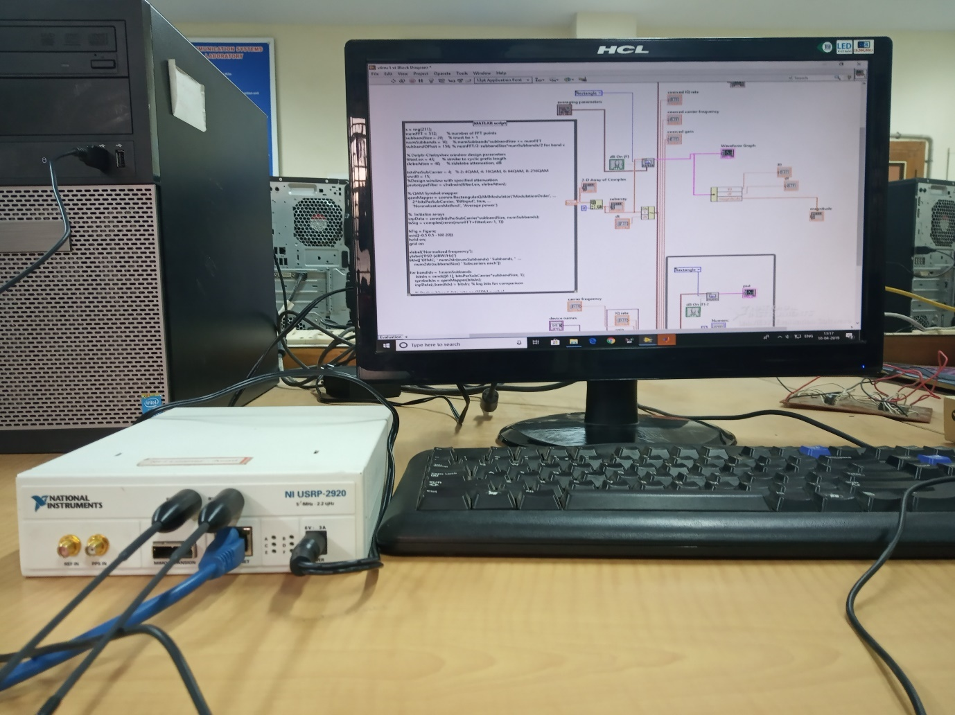

**Fig 5.1 Real time connection of H/W and S/W.**

**5.1.1 TRANSMITTER VIs INTERCONNECTOIN**

1. The signal required to transmit is taken from MATLAB. Here, MATLAB script is interfaced with LABVIEW using MATH SCRIPT MODULE. It will call the MATLAB for processing and return the results. It is shown in fig 5.2.
2. For transmitting that signal there is a four VIs which are **OPEN TX SESSION, CONFIGURE SIGNAL, WRITE TX DATA AND CLOSE SESSION VI.** These 4 VIs are explained earlier.
3. get those VIs, right click on the **Block diagram window**, the **function** palette will appear. Then select **instrument i/o >> instrument drivers >>** **NI USRP >> TX.**
4. A screenshot of a social media post

   Description automatically generated The complex data taken from MATLAB is converted into waveform data type using BUILD WAVEFORM VI and given to WRITE TX DATA VI.

**Fig 5.2 Transmitter**

1. The power spectral density is seen by using PSD VI.
2. To transmit the signal continuously, WRITE TX DATA VI is given in inside of while () loop.
3. Using the STOP Boolean button, the transmission can be terminated.
4. The transmitted UFMC multi carrier signal is shown in Fig5.3. Its corresponding simulation output of UFMC and OFDM PSD is shown in fig5.4 and 5.5.

**Fig5.3 UFMC signal**

**Fig5.4 UFMC simulation output**

**Fig5.5 OFDM simulation result**

**5.1.2 RECEIVER VIs INTERCONNECTION**

1. At the receiver end the reverse operation will take place. To receive the signal using LABVIEW seven VIs must be connected.
2. They are **OPEN RX SESSION, CONFIGURE NO OF SAMPLES, CONFIGURE SIGNAL, INITIATE, FETCH RX DATA, ABORT AND CLOSE SESSION VI.** These 7 VIs are explained in last chapter.
3. To get those VIs, right click on the **Block diagram window**, the **function** palette will appear. Then select **instrument i/o >> instrument drivers >>NI USRP >> RX.**
4. The received signal is given to the MATLAB script using MATH SCRIPT module. The equalization and demodulation are done in MATLAB. The designed receiver block is shown in fig 5.6.

**Fig 5.6 Receiver**

1. FETCH RX DATA VI is given in inside of while () loop for continuous reception. This can be terminated by STOP button.
2. The data taken from FETCH RX DATA VI is in CDB cluster data type. So, the magnitude value is taken by using UNBUNDLE BY NAME VI.
3. The received signal’s PSD density is shown in Fig5.7.
4. The received symbols and its equalized version are shown in Fig5.8 and Fig5.9 respectively.

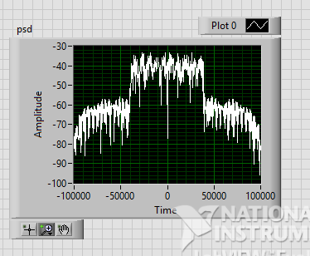

**Fig 5.7 Received UFMC signal PSD**

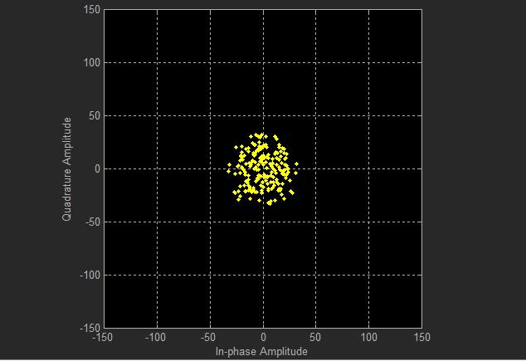

**Fig 5.8 Before equalization**

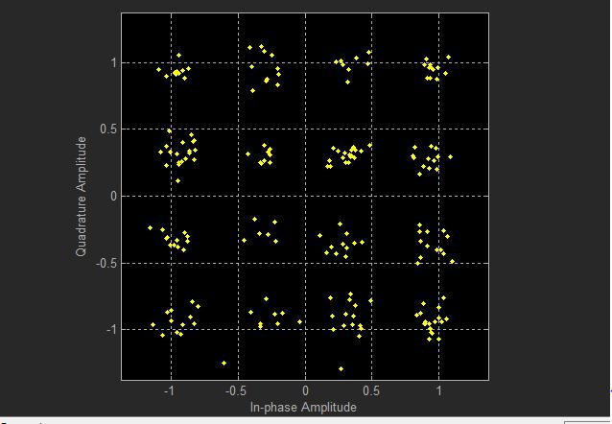

**Fig 5.9 After equalization**

Fig 5.10 depicts the BER curve for different mapping schemes. BER and PAPR of UFMC system for various mapping techniques using MATLAB are listed in Table 5.11. From the Table 5.11 it is observed that BER of UFMC is increasing when number of bits per subcarrier is increasing.

**Fig5.10 BER OF UFMC**

**Table 5.11. BER and PAPR of UFMC for different mapping techniques at 5dB SNR**

|  |  |  |  |
| --- | --- | --- | --- |
| **Mapping**  **Techniques** | **BER of**  **UFMC** | **PAPR of**  **UFMC** | **PAPR of**  **OFDM** |
| **4QAM** | **0.0025** | **9.04** | **8.4377** |
| **16QAM** | **0.0875** | **8.2379** | **8.8843** |
| **64QAM** | **0.18** | **8.6229** | **9.9269** |
| **256 QAM** | **0.24688** | **8.0416** | **7.2553** |

UFMC system BER is small for 4QAM mapping method. The PAPR values of UFMC system are high compared to OFDM except for 16QAM mapping method. Even though BER of UFMC system is less, PAPR of UFMC system is high for 4QAM mapping method. Therefore, compromise between BER and PAPR, 16QAM mapping method is used for UFMC system.

**CHAPTER 6**

**CONCLUSION AND FUTURE WORKS**

The main goal of this project is to implement the UFMC modulation technique using USRP and analyse its parameters. UFMC transmitter and receiver blocks are created using LABVIEW and its parameters are analysed. Because of this implementation its transmission and reception properties can be varied and analysed easily. UFMC system BER is small (0.0025) for 4QAM mapping method. The PAPR values are high compared to OFDM except for 16QAM mapping method (8.2379). Even though BER of UFMC system is less, PAPR of UFMC (9.04) is high for 4QAM. Therefore, compromise between BER and PAPR, 16QAM is used for UFMC system.

**FURTURE WORKS:**

Instead of zero forcing equalizer, LMS equalizer can be used to reduce the SER further low. Though QAM mapping method provides efficient mapping, alternatives can be used to optimize the system.

**REFERENCES**

1. Frank Schaich, Thorsten Wild, Yejian Chen,”Waveform Contenders for 5g – Suitability for Short Packet and Low Latency Transmissions”, Vehicular Technology Conference, 2014, pp. 1-5.
2. G.Wunder, P. jung, M. Kasparick, F. Schaich, Y. Chen, S. Brink, I. Gasper, N.Michailow, A. Festag, L. Mendes, N. Cassiau, D. Ktenas, M. Dryjanski, S. Picerzykr, B. Eged, P. vago, and F. Wiedmann, “ 5GNOW: Nonorthogonal, Asynchronous Waveforms for Future Mobile Applications”, Communication Magazine, IEEE, vol. 52, February 2014, pp.97-105.
3. Suiyan Geng, Xin Xiong, Linlin Cheng, Xiongwen Zhao, Biao Huang, “UFMC system performance analysis for discrete narrowband private networks”, Microwave, Antenna, Propagation, and EMC Technologies (MAPE),2015 IEEE 6th International Symposium, 14 July 2016.
4. Mounira Laabidi, Rafik Zayani, Daniel Roviras, Ridha Bouallegue, “PAPR reduction in FBMC/OQAM systems using active constellation extension and tone reservation approaches”, IEEE symposium on Computers and Communication(ISCC), July 6, 2015 to July 9, 2015, pp.657-662.
5. Frank Schaich, Thorsten Wild, Yejian Chen, “5G air interface design based on Universal Filtered (UF-) OFDM”, Proc. Of 19th International Conference on Digital Signal Processing, 2014, pp. 699-704.
6. K. Meena Anusha, Dr. Ch. Santhi Rani, ”Performance Analysis of OFDM-OSTBC system under Various Fading Channels using Different Doppler Spectra”, International Conference on Electrical, Electronics, and Optimization Techniques (ICEEOT) -2016.
7. Sathiyapriya N.S, “ Implementation and study of universal Filtered Multi Carrier Under Carrier Frequency Offset For 5G”,IPASJ International Journal of Electronics and Communication (IIJEC), April 2016, volume 4, Issue 4, pp.1-5.

[8] G. Wunder, M. Kasparick, S. ten Brink, F. Schaich, T. Wild, I. Gaspar, E. Ohlmer, S. Krone, N. Michailow, A. Navarro, G. Fettweis, D. Ktenas, V. Berg, M. Dryjanski, S. Pietrzyk, and B. Eged, “5gnow: Challenging the lte design paradigms of orthogonality and synchronicity,” in Vehicular Technology Conference (VTC Spring), 2013 IEEE 77th, June 2013, pp. 1–5.

[9] G. Wunder, P. Jung, M. Kasparick, T. Wild, F. Schaich, Y. Chen, S. Brink, I. Gaspar, N. Michailow, A. Festag, L. Mendes, N. Cassiau, D. Ktenas, M. Dryjanski, S. Pietrzyk, B. Eged, P. Vago, and F. Wiedmann, “5gnow: non-orthogonal, asynchronous waveforms for future mobile applications,” Communications Magazine, IEEE, vol. 52, no. 2, pp.97– 105, February 2014

.

[10]B. Farhang-Boroujeny, “Ofdm versus filter bank multicarrier,” Signal Processing Magazine, IEEE, vol. 28, no. 3, pp. 92–112, May 2011.

[11] V. Vakilian, T. Wild, F. Schaich, S. ten Brink, and J.-F. Frigon, “Universal-filtered multicarrier technique for wireless systems beyond LTE,” in 2013 IEEE Globecom Workshops (GC Wkshps), Dec 2013, pp. 223–228.

[12] T. Wild, F. Schaich, and Y. Chen, “5G Air Interface Design based on Universal Filtered (UF-)OFDM,” in Int. Conf. on Dig. Sig. Processing (DSP’14), August 2014.